ECON 7008 Macroeconomics 2 Spring 2012 Qualifier
For each question below, points (for a total of 50) are indicated.

- Goodwin dynamics in three phase diagrams:
  - (12 points) Compare and contrast! Discuss theoretical, conceptual and mathematical differences and similarities. (You do not need to go into mathematical detail; simply discuss underlying assumptions and resulting model properties.)
  - (7 points) Discuss the assertion that the three models below are misspecified because they lack a financial sector.

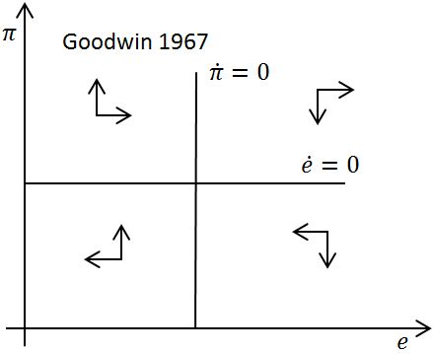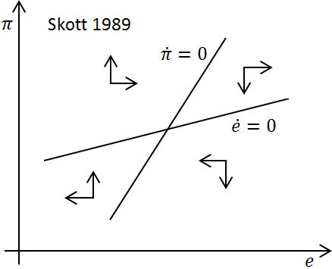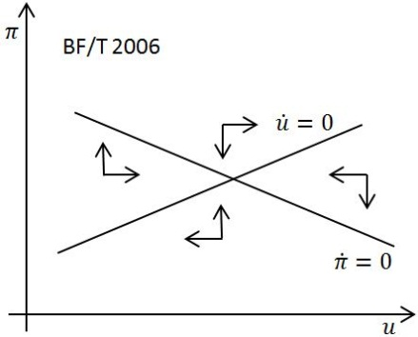

- Demand and distribution: (12 points) Set up a model in the rate of utilization $u=Y/K$ and real unit labor costs $ψ=ω/ξ$. Assume partial goods market adjustment with Neo-Kaleckian accumulation $g[u,ψ]$ and savings $s[ψ]u$; and partial distributive adjustment with a real wage curve $ω[e]$, where $e=L/N$ is the employment rate, and a Kaldor-Verdoorn type productivity rule $ξ[u]$. Discuss model properties and derive a phase diagram, making further assumptions as needed.

- The Ramsey tale: Once upon a time in a far away land a population of $N$ individuals with identical logarithmic preferences $u=\ln{c}$, growing at rate $n=1/50$, used a Cobb-Douglas production function with constant returns to scale and capital share parameter $α=1/2$ to produce output$Y$. Every day, they could decide what to consume now, and what to invest for later. One of them—she had perfect foresight—decided to maximize aggregate utility, once and for all. Fortunately, capital depreciated slowly, $δ=2/100$, and she deemed a time discount rate of $ρ=3/100$ appropriate.
  - (12 points) Assume you're the one! Set up the maximization problem, show the current-value Hamiltonian, analyze the resulting (numerical!) system of differential equations, and illustrate with a phase diagram. Briefly explain.
  - (7 points) Linearize the (numerical!) system around the steady state, and derive the linearized phase diagram. Briefly explain.

